Investigation of Turn-on and Turn-off Characteristics of   
Enhancement-Mode GaN Power Transistors

**Abstract:** In this paper, turn-on and turn-off switching behavior of 650V enhancement-mode GaN power FETs are investigated. An analytical model is developed to analyze the current-voltage characteristics of the device during switching transients both with and without the effects of parasitic components.

1. **Introduction**

Wide band-gap power semiconductor devices such as Silicon Carbide (SiC) and Gallium Nitride (GaN) are becoming more widespread each day, thanks to their superior efficiency and power density performance over Silicon (Si) based power semiconductor devices. Although current GaN devices are available at lower voltage (< 650V) and lower current (< 50A) ratings, they have become an attractive solution in several power converter applications. Several enhancement-mode (e-mode) GaN transistors are now commercially available up to 650 V ratings, which have better performance than cascode devices in terms of switching speed, Rds-on and reverse conduction. E-mode GaN FETs have low specific Rds-on due to their high breakdown field as well as high electron mobility. They can be manufactured with smaller size so that the parasitic components due to packaging are lower resulting in faster switching [1]. Switching losses of these devices are much lower compared to their Si counterparts, and this allows them to be used in high frequency applications where passive components can be made smaller.

Investigation of switching behavior of GaN power FETs is important for several reasons. First of all, high switching speed of GaNs make them more vulnerable to *di/dt* and *dv/dt* effects and parasitic components. Second, e-mode GaNs have reverse conduction capability without an intrinsic or external diode [2]. They act as a resistor just like MOSFETs in forward conduction; however, their behavior in reverse conduction is different than forward conduction, varying with the applied gate-source (*Vgs*) voltage. Therefore, turn-on and turn-off characteristics are dependent on applied gate-source voltage. Usually, a negative gate voltage is required to avoid false turn-on which results in a much higher on-state voltage when the device is not actively turn-on during dead-time [3]. Another reason is that, their switching loss and reverse conduction loss model is not the same as Si MOSFETs. Although dead-time period and its effects on power loss calculations are usually ignored in other applications, it may affect the converter efficiency significantly in e-mode GaN applications [3].

Several recent studies have been published regarding e-mode GaN FET modeling. In [4], the *Ids-Vds*, *Ids-Vgs* characteristics and dynamic *Rds-on* behavior of e-mode GaNs are obtained using curve fitting from experimental data. An analytical model is applied with steady-state behavior with temperature dependency and dynamic response with varying input and output capacitances in [5]. A mode-by-mode analysis is investigated in [6] for estimating the switching losses under various parasitic effects using small-signal models. The false turn-on phenomenon its relationship with the applied *Vgs* voltage are investigated in [3]. Several methods have been proposed for the minimization of the reverse conduction losses such as using a schottky diode in parallel with the synchronous GaN transistor [3]. In this paper, a hybrid model is proposed for the investigation of steady-state dynamic behavior and the switching transients of e-mode GaN power FETs. The state trajectories of the device during the turn-on and turn-off periods are obtained. the active turn-on and passive turn-on characteristics of the device are investigated on a synchronous buck converter. the effect of varying device capacitances and parasitic inductances on these trajectories and their possible outcomes are studied.

1. **GaN Modeling**

There are several modeling techniques applied to power semiconductor devices as mentioned before. In this study, a hybrid model is proposed which is shown in Fig. 1. In this model, the drain-source characteristics is modeled by a dependent current source and a temperature dependent resistance which gives the steady state behavior of the device during forward and reverse conduction at different Vgs values. The analysis during switching transients will be located onto Ids – Vds characteristics to show the regions where the device operates during these transient periods. The equations used for steady-state models are shown in Eqn. (1) and (2) for forward conduction and reverse conduction, respectively. These equations correspond to the *Ids-Vds* curves of the device and the dynamic Rds-on, derived from the manufacturer’s models. The first multiplier of the equations represents the trans-conductance of the device where Vth is the threshold voltage. The second multiplier represents the region in which the device is operating; i.e., active region or ohmic region. *Rt* represents the temperature dependency of *Rds-on* in the model given in Fig. 1. Using this model, both steady-state and transient behavior of the conduction path are obtained. The model is used in MATLAB/Simulink with a single-leg converter (synchronous rectifier) to investigate the switching behavior as shown in Fig. 1. The nominal values of this test circuit used for the simulations are listed in Table 1.



Fig.1(a) Proposed hybrid model of e-mode GaN power FET Fig. 1(b) The single leg converter used for the analysis

|  |  |
| --- | --- |
|  | (1) |
|  | (2) |

To show the accuracy of the steady state models, *Ids-Vds* characteristics of the selected device (GS66508B from GaN Systems) at different applied *Vgs* is obtained in both forward and reverse conduction regions at 25 0C, and plotted side-by-side with the actual characteristics given in the datasheet of the selected device [7] in Fig. 2. As shown, the reverse conduction behavior is highly dependent on the applied gate voltage, and shows a different behavior at negative gate voltage. In free-wheeling modes, this should make no difference since the applied gate voltage is positive. However, during dead-time periods, a negative gate voltage is applied increasing the loss, which makes the optimization of the negative gate voltage and dead-time duration very critical.

  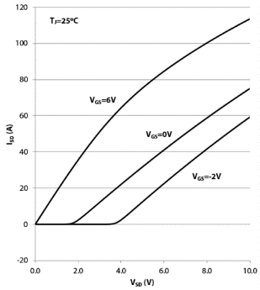

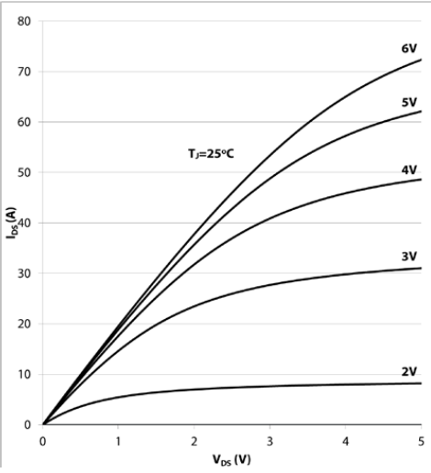

(a) Forward conduction (model) (b) Forward conduction (actual) (c) Reverse conduction (model) (d) Reverse conduction (actual)

Fig.2. Steady-state characteristics of GS66508B obtained by the proposed model and the actual characteristics [7]

The second critical part of the model includes the capacitances which determine the transient behavior of the device during switching operation as shown in Fig. 1. Although the values of these capacitances are usually given in the datasheets at rated voltages, that kind of a model will not be accurate as they are dependent on voltage. Therefore, it may change the behavior of the device during turn-on and turn-off periods, and should be taken into account. In this study, these variable capacitances are modeled using curve fitting obtained from the datasheet, and the resulting characteristics is shown in Fig. 3 [7].



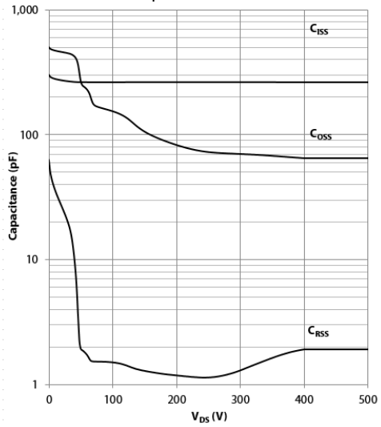

(a) Model (b) Datasheet

Fig.3. Modeling of the capacitances using curve fitting

1. **Switching Behavior of GaN**

For better understanding of the switching behavior of e-mode GaNs, the turn-on and turn-off behavior of the selected device is investigated step-by-step using three models:

1. The simplest model with constant capacitances and without parasitic inductances,
2. The model with variable capacitances and without parasitic inductances,
3. The most practical model with variable capacitances and without parasitic inductances.

The nominal values of this test circuit used for the simulations are listed in Table 1, along with the device datasheet parameters used.

Table 1. The parameters used for the test circuit in MATLAB/Simulink

|  |  |  |  |  |  |
| --- | --- | --- | --- | --- | --- |
| Input voltage (Vd) | 400 V | Gate parasitic inductance (Lg) | 1.0 nH | Dead-time (tdead) | 10 ns |
| Output voltage (Vo) | 200 V | Internal gate resistance (Rg) | 1.5 Ω | Filter inductance (Lf) | 10 µH |
| Output power (Po) | 3 kW | Turn-on gate resistance (RG-ON) | 20 Ω | Filter capacitance (Cf) | 220 nF |
| Applied gate voltage (Vgs) | -3V/+6V | Turn-off gate resistance (RG-OFF) | 5 Ω | Drain/source inductances (Ld/Ls) | 0.9 nH |

For simplicity, the control switch is going to be labeled as “Top Switch” and the synchronous switch is going to be labeled as “Bottom Switch” from now on, in the synchronous buck converter. For the simplest model described above, turn-on and turn-off characteristics of the top and bottom switches are obtained against time and can be seen in Fig. 5.



(a) Top switch turn-on (b) Top switch turn-off (c) Bottom switch turn-off (d) Bottom switch turn-on

Fig. 5. Switching characteristics in time domain obtained using the simplest model

Rather than giving the drain-source current, the channel current is preferred to show the device characteristic better. For transient periods, since the parasitic capacitors’ voltages increase or decrease, their currents affect the drain-source current which overshadows device characteristic. As shown in simplest model, Figure 5(a), when the Top Switch is being turned on, since Bottom Switch stops conducting and to charge the COSS (=Cgd +Cds) of the Bottom Switch and since COSS of the Top Switch is discharged which causes current flowing through the channel, Top Switch channel current makes an overshoot. Additionally, even though it seems soft switching is applied on Bottom Switch, actually it is not because COSS of the Bottom Switch is charged or discharged during transient periods and it would be seen if the current was IDS instead of channel current. Note that the main characteristics observed in simplest model are important to understand GaN behavior because in complicated models even though these characteristics exist it might be hard to catch them among the oscillations.

In the next step, the capacitances values which were kept constant at their rated values previously are treated as variable capacitances using the capacitance models presented in Section II. As shown in Figure 3, the capacitances change with respect to the applied drain-source voltage. Contrary to CISS, there are significant changes in COSS and CRSS.The turn-on and turn-off characteristics of the top and bottom switches are obtained against time and can be seen in Fig. 5.

   

(a) Top switch turn-on (b) Top switch turn-off (c) Bottom switch turn-off (d) Bottom switch turn-on

Fig. 5. Switching characteristics in time domain obtained using variable capacitance model

In the variable-capacitance model it is observed that the overshoot in Top Switch channel current increased because for lower drain-source voltages, COSS is greater which results in higher current flow under similar voltage change in time. Moreover, for all transient periods given in Figure 5, it is observed that the voltage changes are smoother which makes the model more realistic. Plus, those different change rates of voltage affect the channel current and that is why small dips and peaks are observed on current waveforms.

Finally, to see the effect of the oscillations created by the LC resonance paths, the parasitic inductances are added to the model which are caused by Packaging (internal), Busbars, conducting parts on the Dc side, Capacitor ESLs etc…

   

(a) Top switch turn-on (b) Top switch turn-off (c) Bottom switch turn-off (d) Bottom switch turn-on

Fig. 5. Switching characteristics in time domain obtained using the model with parasitics

In the most complicated model in which all parasitic effects are included, the oscillations started to be observed due to the energy transferring between parasitic capacitances and inductors.

For a better visualization of these transients, the *Ich, Vds* paths that the top and bottom switches follow during turn-on and turn-off times are also obtained as state trajectories and shown in Fig.6.

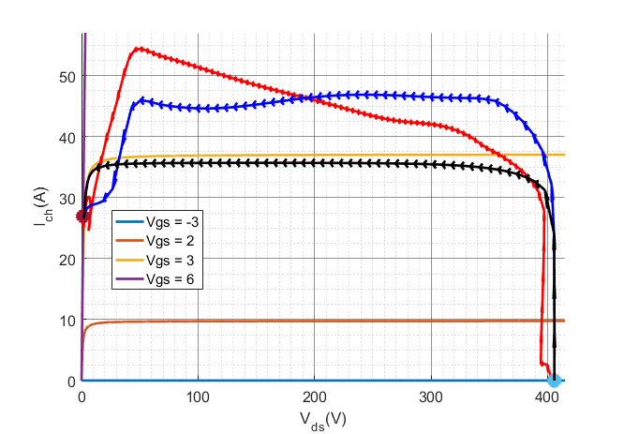 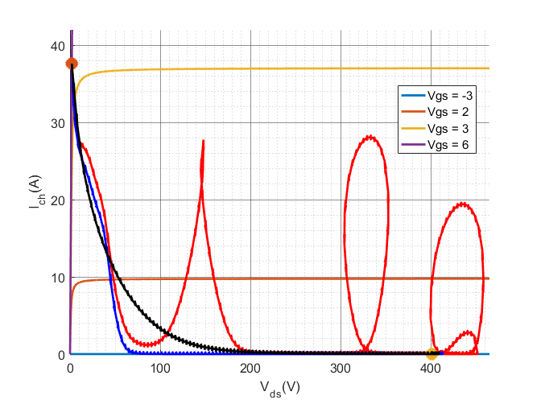

(a) Top switch turn-on (b) Top switch turn-off

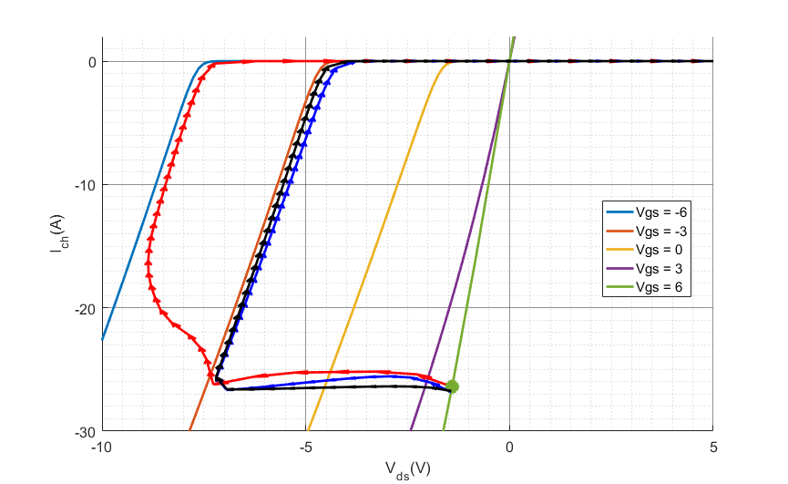 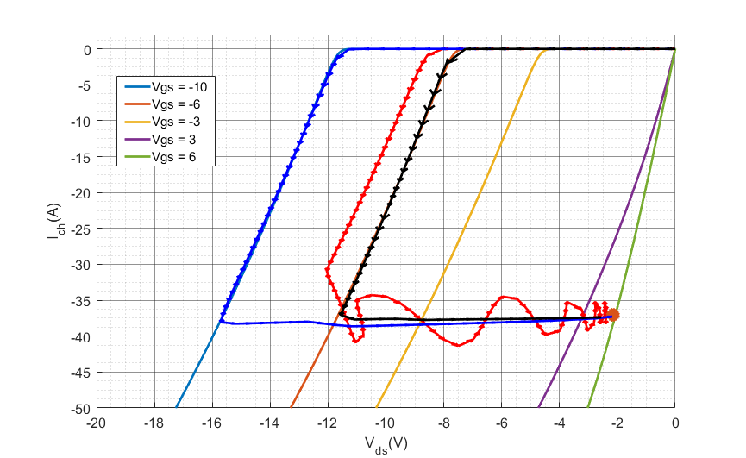

(c) Bottom switch turn-off (d) bottom switch turn-on

Fig 6. Switching characteristics as state trajectories (obtained using all the models)

1. **Conclusions**

Hepsini toplayalım, Konu, objective, Problem, motivasyon, Çözüm, method, Beklentiler, çıktılar, çıkarımlar

In the final paper (çok yer kalmadı ama…..)

1. **References**

[1] E. A. Jones, F. F. Wang, and D. Costinett, “Review of Commercial GaN Power Devices and GaN-Based Converter Design Challenges,” *IEEE J. Emerg. Sel. Top. Power Electron.*, vol. 4, no. 3, pp. 707–719, 2016.

[2] E. A. Jones, F. Wang, and B. Ozpineci, “Application-based review of GaN HFETs,” *2nd IEEE Work. Wide Bandgap Power Devices Appl. WiPDA 2014*, pp. 24–29, 2014.

[3] R. Xie, H. Wang, G. Tang, X. Yang, and K. J. Chen, “An Analytical Model for False Turn-On Evaluation of High-Voltage Enhancement-Mode GaN Transistor in Bridge-Leg Configuration,” *IEEE Trans. Power Electron.*, vol. 32, no. 8, pp. 6416–6433, 2017.

[4] E. A. Jones, F. Wang, D. Costinett, Z. Zhang, B. Guo, B. Liu, and R. Ren, “Characterization of an enhancement-mode 650-V GaN HFET,” *2015 IEEE Energy Convers. Congr. Expo. ECCE 2015*, pp. 400–407, 2015.

[5] K. Peng, S. Eskandari, and E. Santi, “Characterization and Modeling of a Gallium Nitride Power HEMT,” *IEEE Trans. Ind. Appl.*, vol. 52, no. 6, pp. 4965–4975, 2016.

[6] K. Wang, X. Yang, H. Li, H. Ma, X. Zeng, and W. Chen, “An Analytical Switching Process Model of Low-Voltage eGaN HEMTs for Loss Calculation,” *IEEE Trans. Power Electron.*, vol. 31, no. 1, pp. 635–647, 2016.

[7] GaN Systems, “GS66508P Bottom-side cooled 650 V E-mode GaN transistor Preliminary Datasheet,” pp. 1–13, 2016.